1. **What are the different margins options and do we adjust the margins of**

**the excel worksheet?**

In Microsoft Excel, you can adjust the margins of a worksheet to control the amount of space between the content and the edges of the printed page. Margins can be adjusted to ensure that your data is correctly formatted and fits well on the printed page.

1. **Set a background for your table created.**

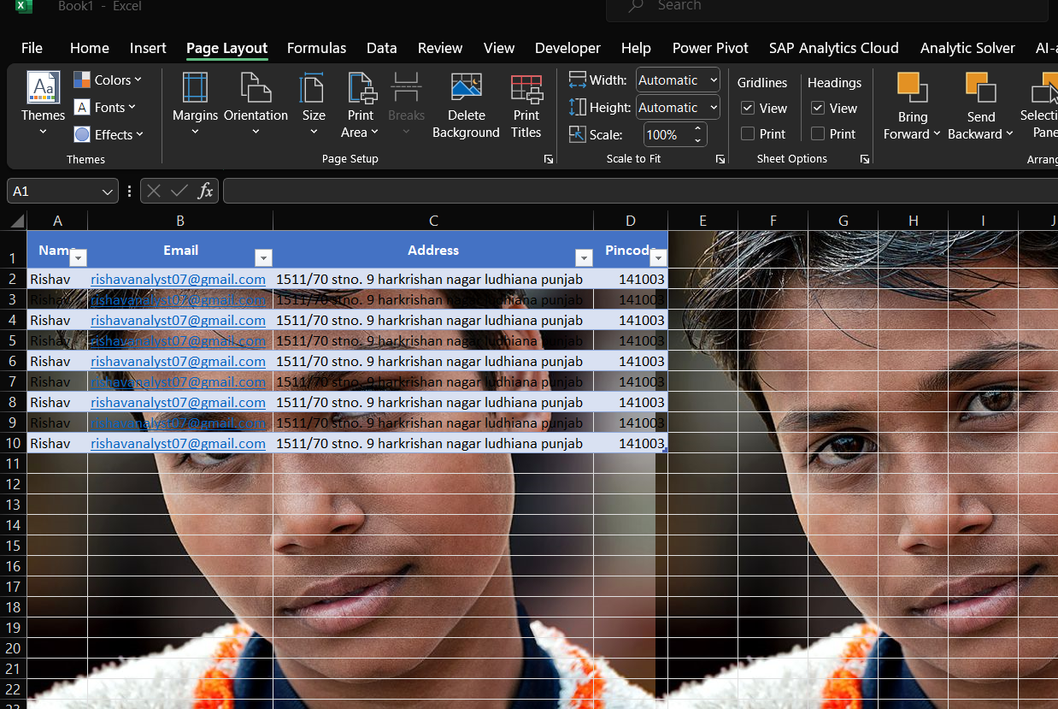

1. **What is freeze panes and why do we use freeze panes? Give**

**examples.**

"Freeze Panes" is a feature in Microsoft Excel that allows you to lock specific rows or columns so that they remain visible while scrolling through the rest of the worksheet. This can be particularly useful when working with large datasets or tables where you want to keep certain headers or labels visible at all times.

Why Use Freeze Panes:

The primary purpose of using Freeze Panes is to maintain the visibility of important information, such as column or row headers, as you navigate through large sets of data. This helps users keep track of the context of the data they are viewing. Without Freeze Panes, as you scroll down or to the right in a worksheet, headers may disappear, making it challenging to understand the meaning of the data.

1. **What are the different features available within the Freeze Panes**

**command?**

The "Freeze Panes" command in Microsoft Excel provides options to lock specific rows or columns in a worksheet to keep them visible while scrolling. Here are the main features available within the "Freeze Panes" command:

1. Freeze Top Row:

Usage:

Keeps the top row of the worksheet visible while scrolling down.

How to Use:

Select the row just below the row you want to freeze.

Go to the "View" tab, click on "Freeze Panes," and choose "Freeze Top Row."

2. Freeze First Column:

Usage:

Keeps the first column of the worksheet visible while scrolling to the right.

How to Use:

Select the column just to the right of the column you want to freeze.

Go to the "View" tab, click on "Freeze Panes," and choose "Freeze First Column."

3. Freeze Panes:

Usage:

Keeps both the rows above and the columns to the left of the selected cell visible while scrolling.

How to Use:

Select the cell below and to the right of the rows and columns you want to freeze.

Go to the "View" tab, click on "Freeze Panes," and choose "Freeze Panes."

1. **Explain what the different sheet options present in excel are and what**

**they do?**

In Microsoft Excel, sheet options refer to various settings and features that allow you to customize and manage individual worksheets within a workbook. These options help you control the appearance, behavior, and functionality of each sheet. Here are some common sheet options and what they do:

1. Rename Sheet:

Description:

Allows you to change the name of the current sheet.

How to Use:

Right-click on the sheet tab at the bottom, select "Rename," and enter a new name.

2. Insert Worksheet:

Description:

Adds a new worksheet to the workbook.

How to Use:

Right-click on a sheet tab, select "Insert," and choose "Worksheet."

3. Delete Worksheet:

Description:

Removes the current sheet from the workbook.

How to Use:

Right-click on a sheet tab, select "Delete," and confirm the deletion.